Ch-3   
  
pwd – lets you know where you are:-

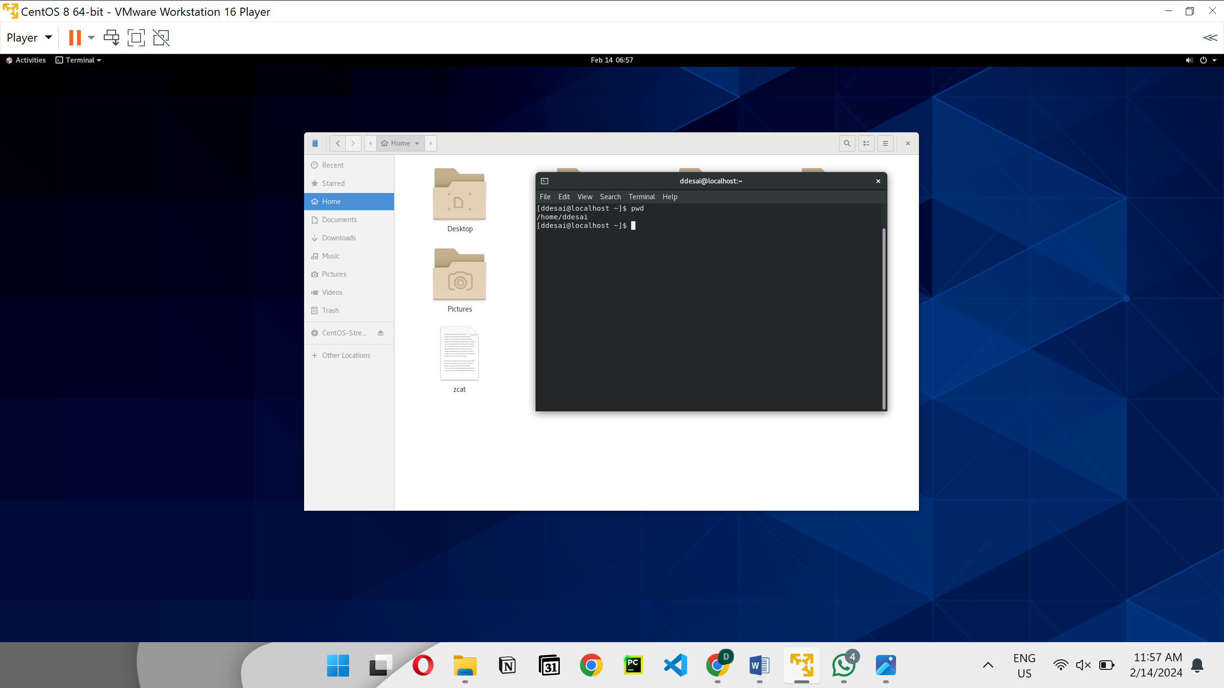

Ls- **ls** command lists directory contents for the specified directory

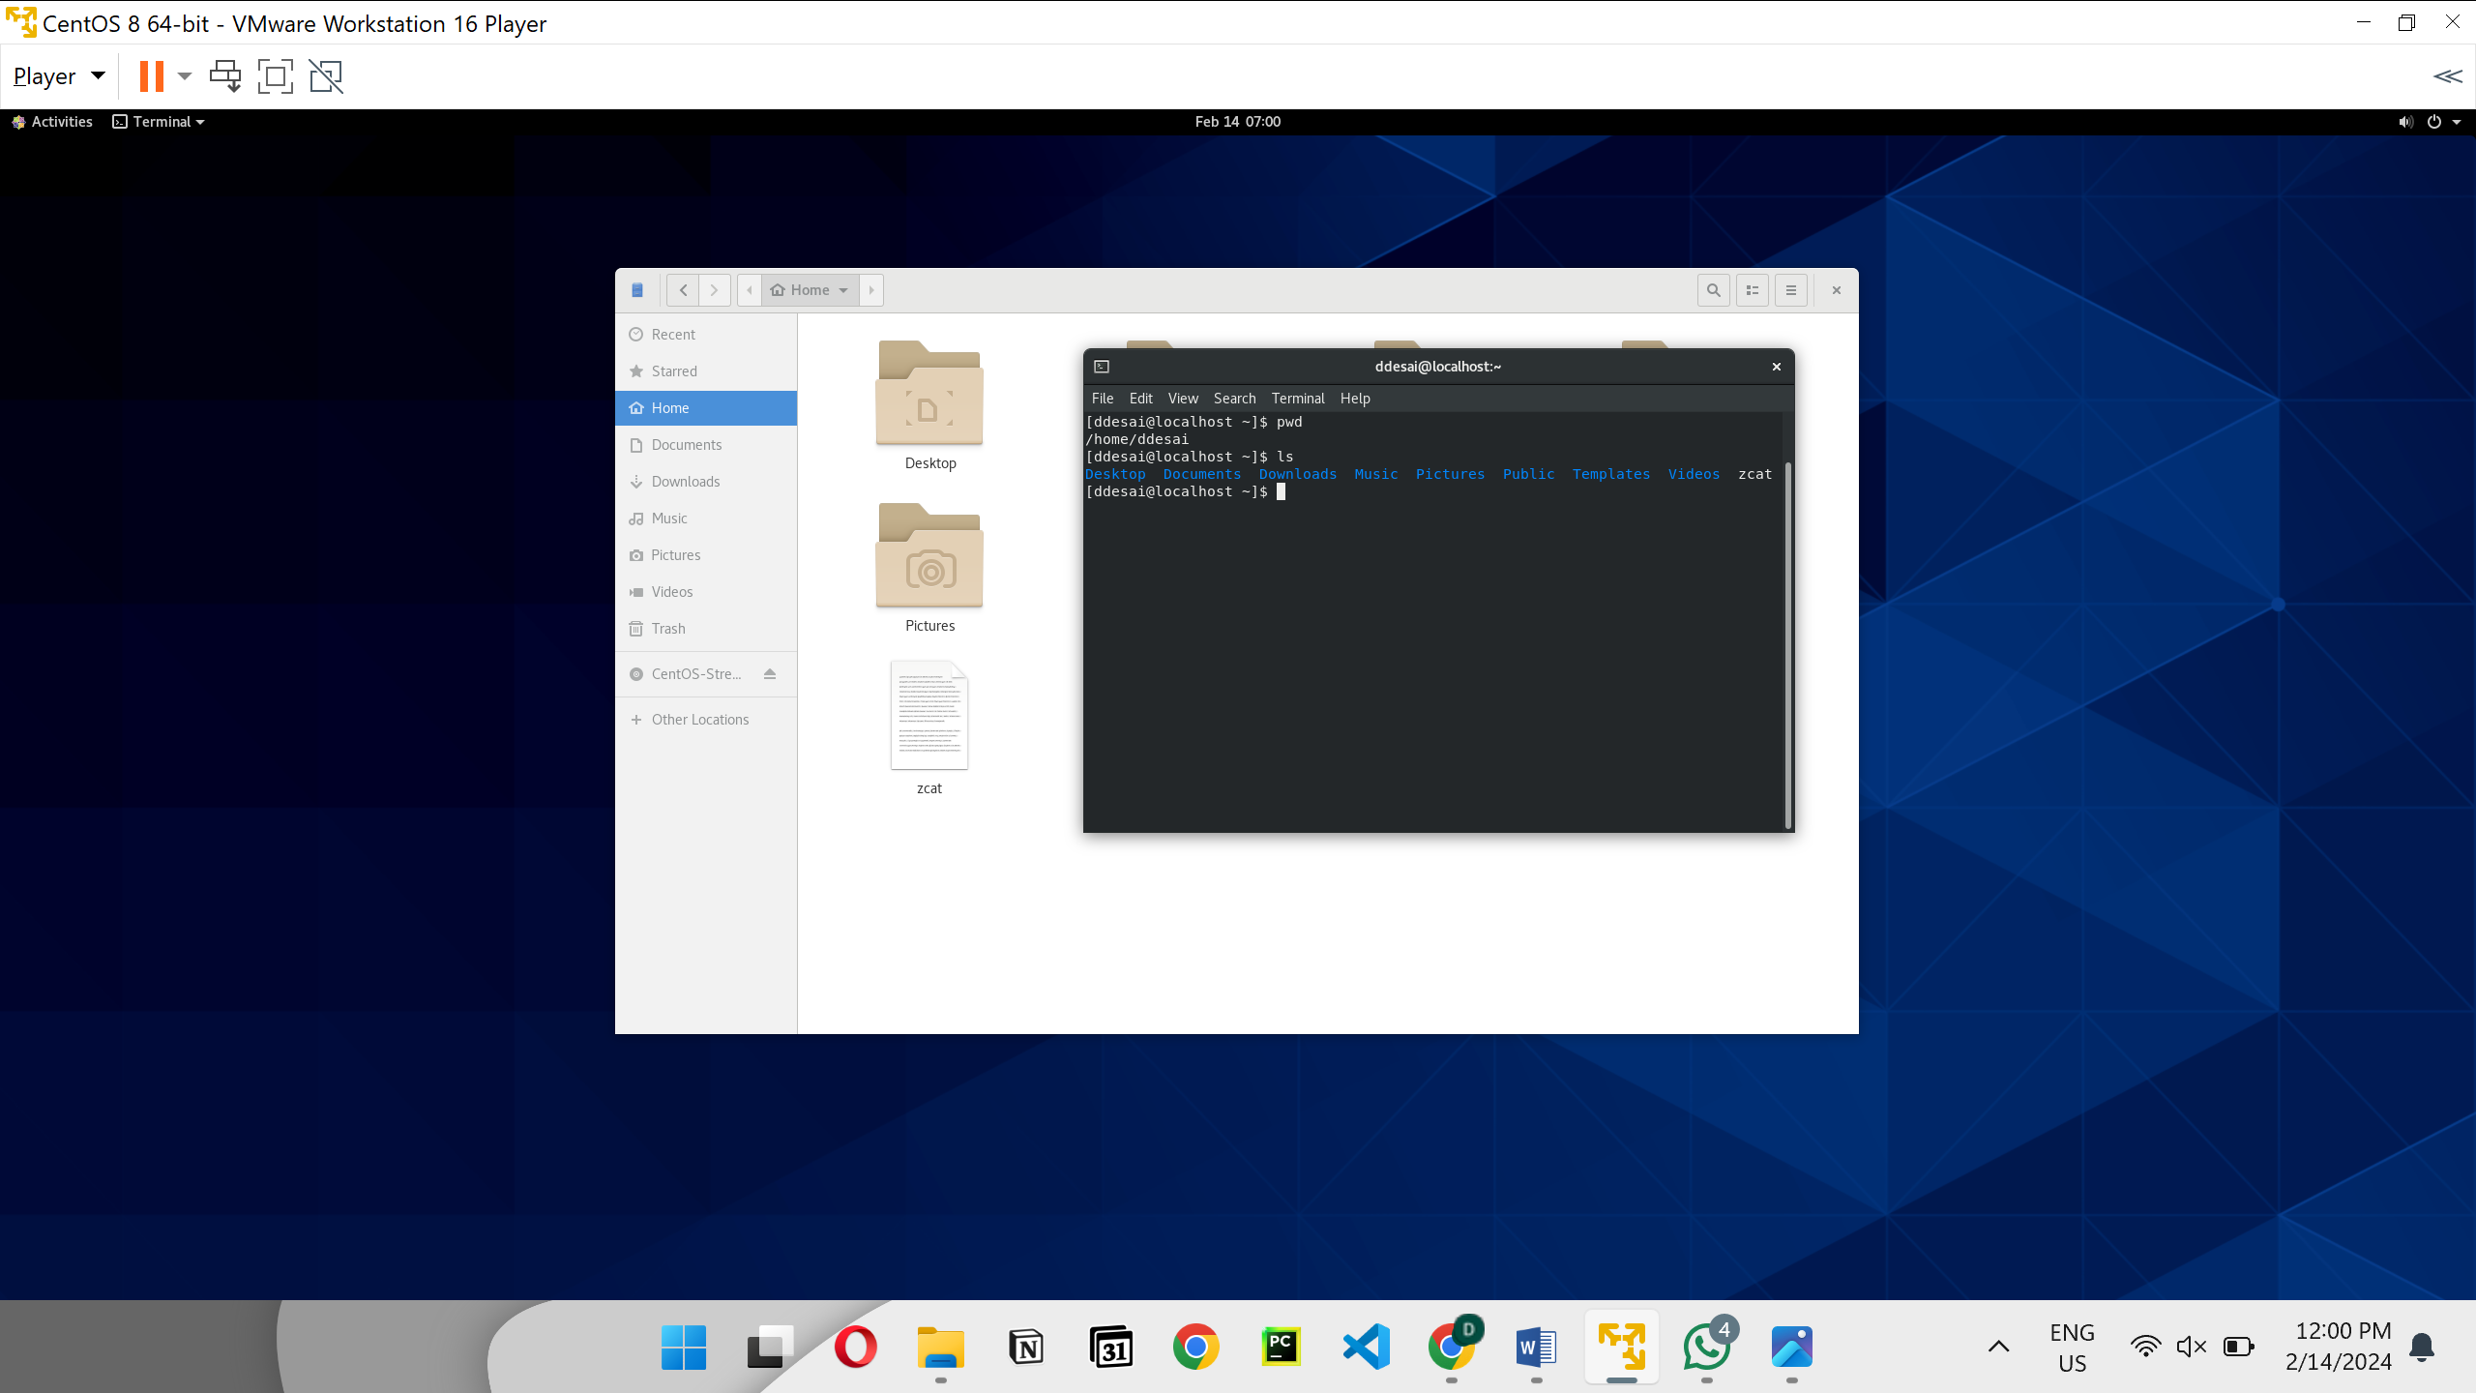

* ~ you are in home directory

ls -l

ls /etc  
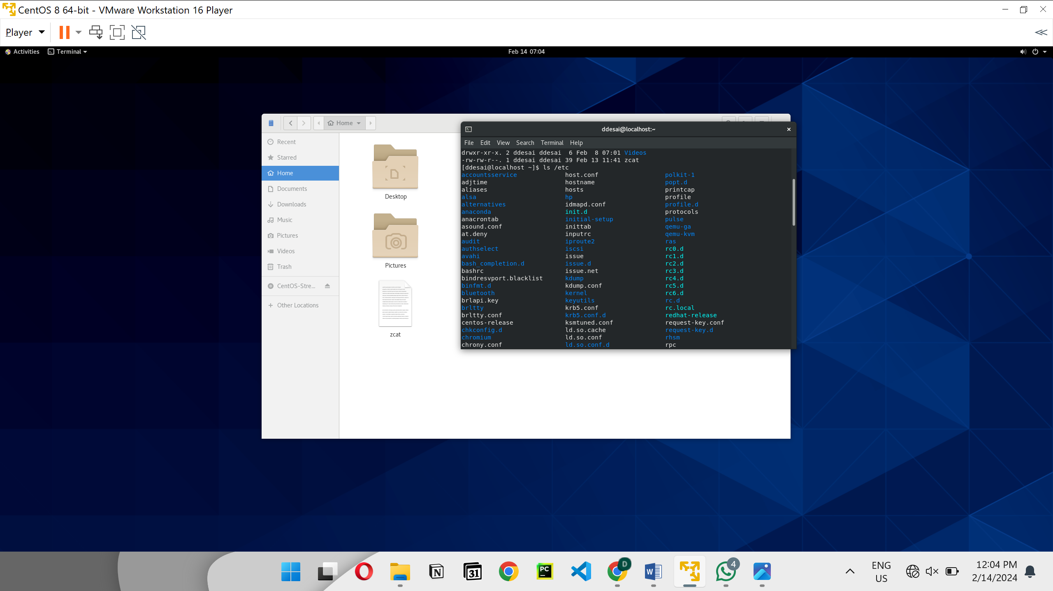

ls /

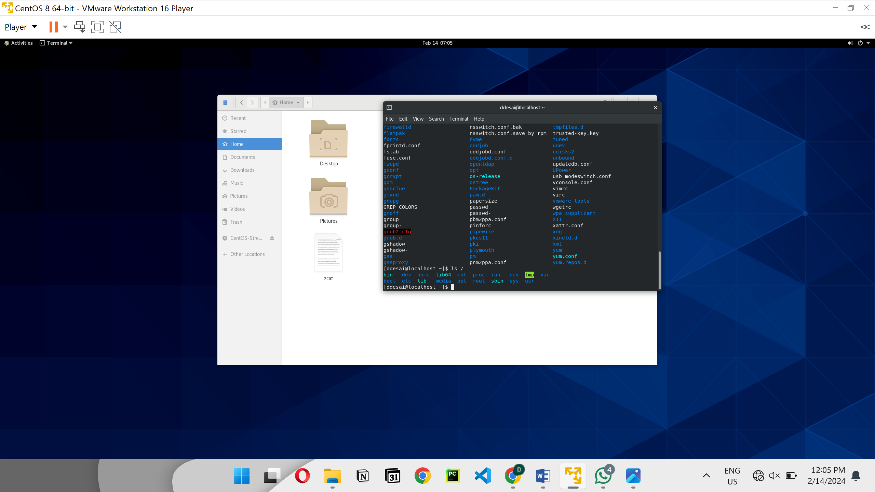

Touch batch24.txt

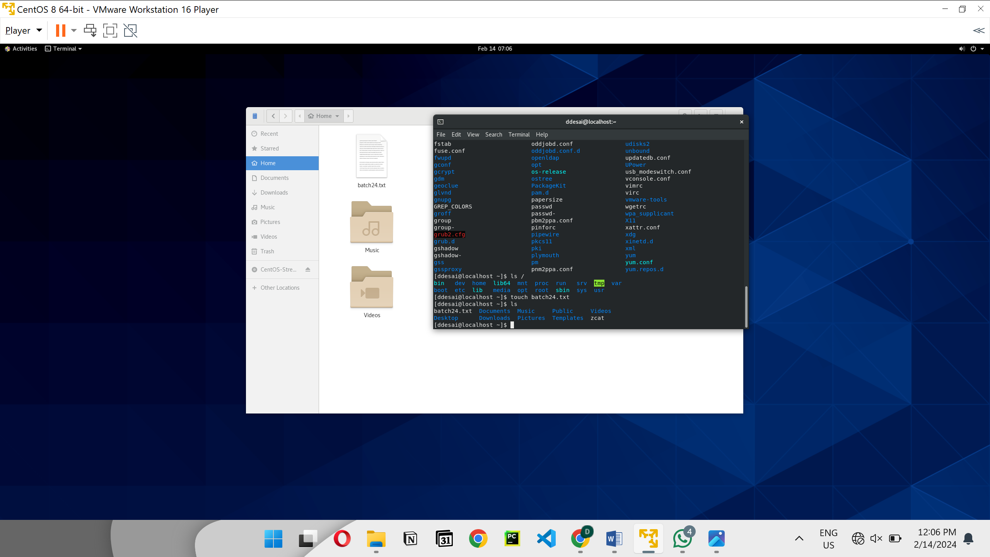

cat batch24.txt🡪 To see info of file

vi🡪 is defalt text editer

step-1 vi batch24.txt

step-2 i

step-3 esc and :wq

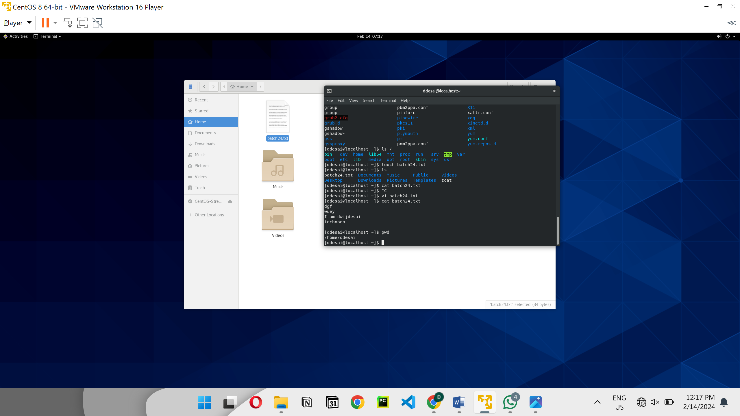

Cd 🡪Change directory.

To go to parnt file 🡪 ‘cd ..’

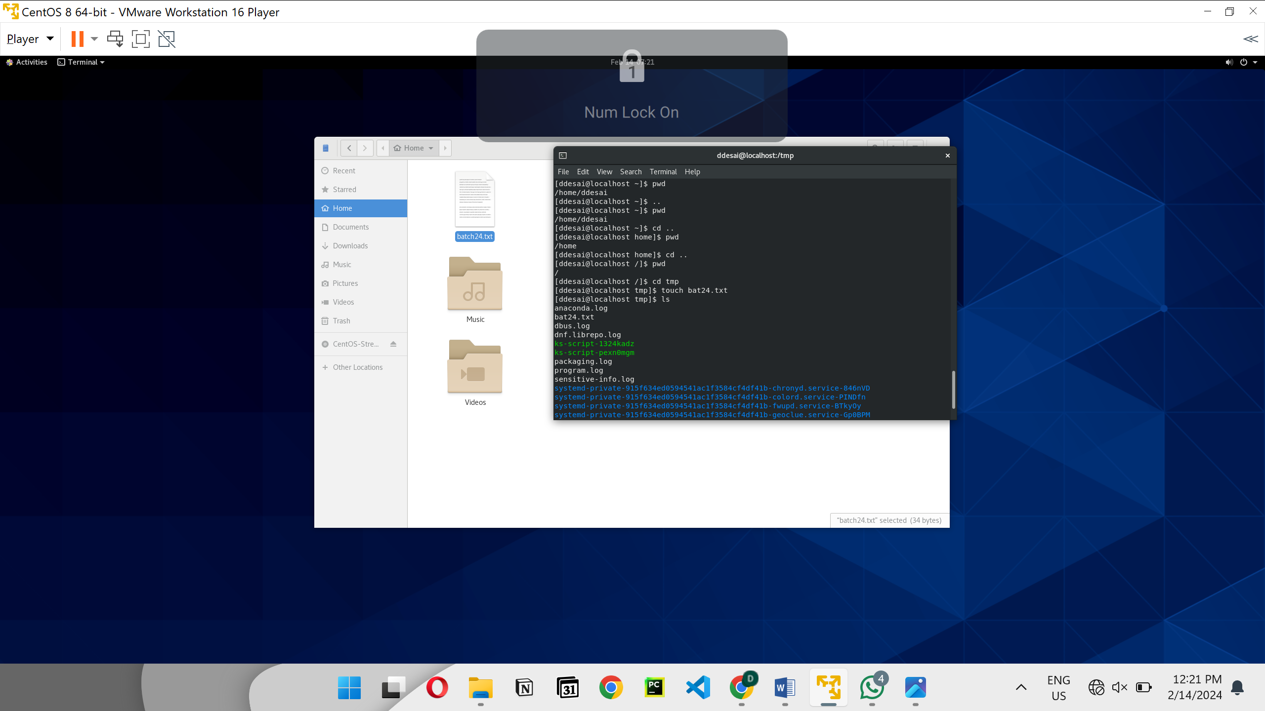

‘Cd /home/ddesai’ to get in that folder

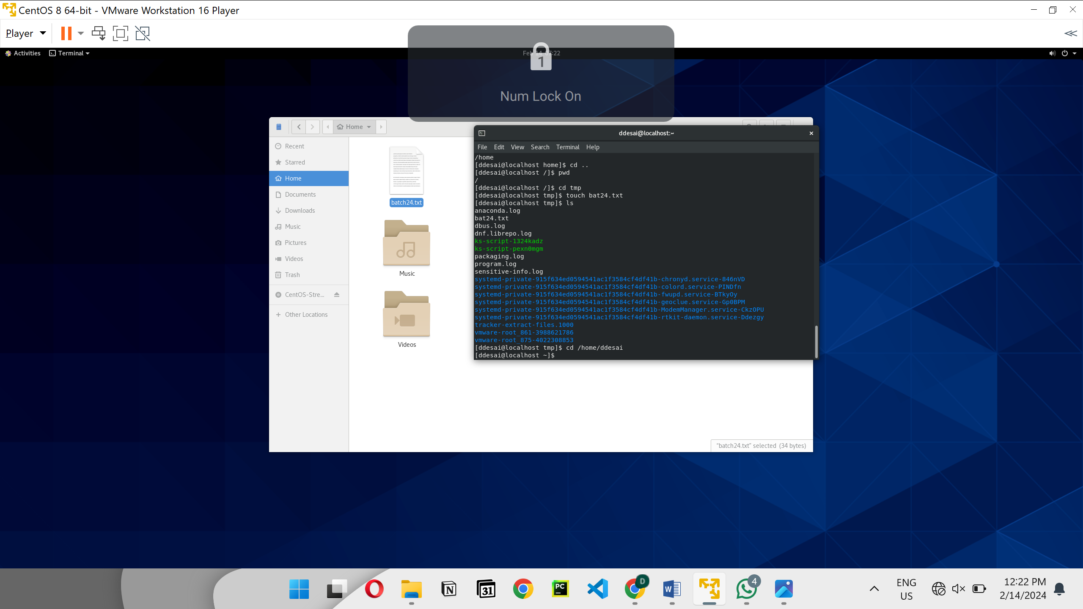

To write file in tmp from ddesai

* touch /tmp/b242.txt
* ls /tmp/

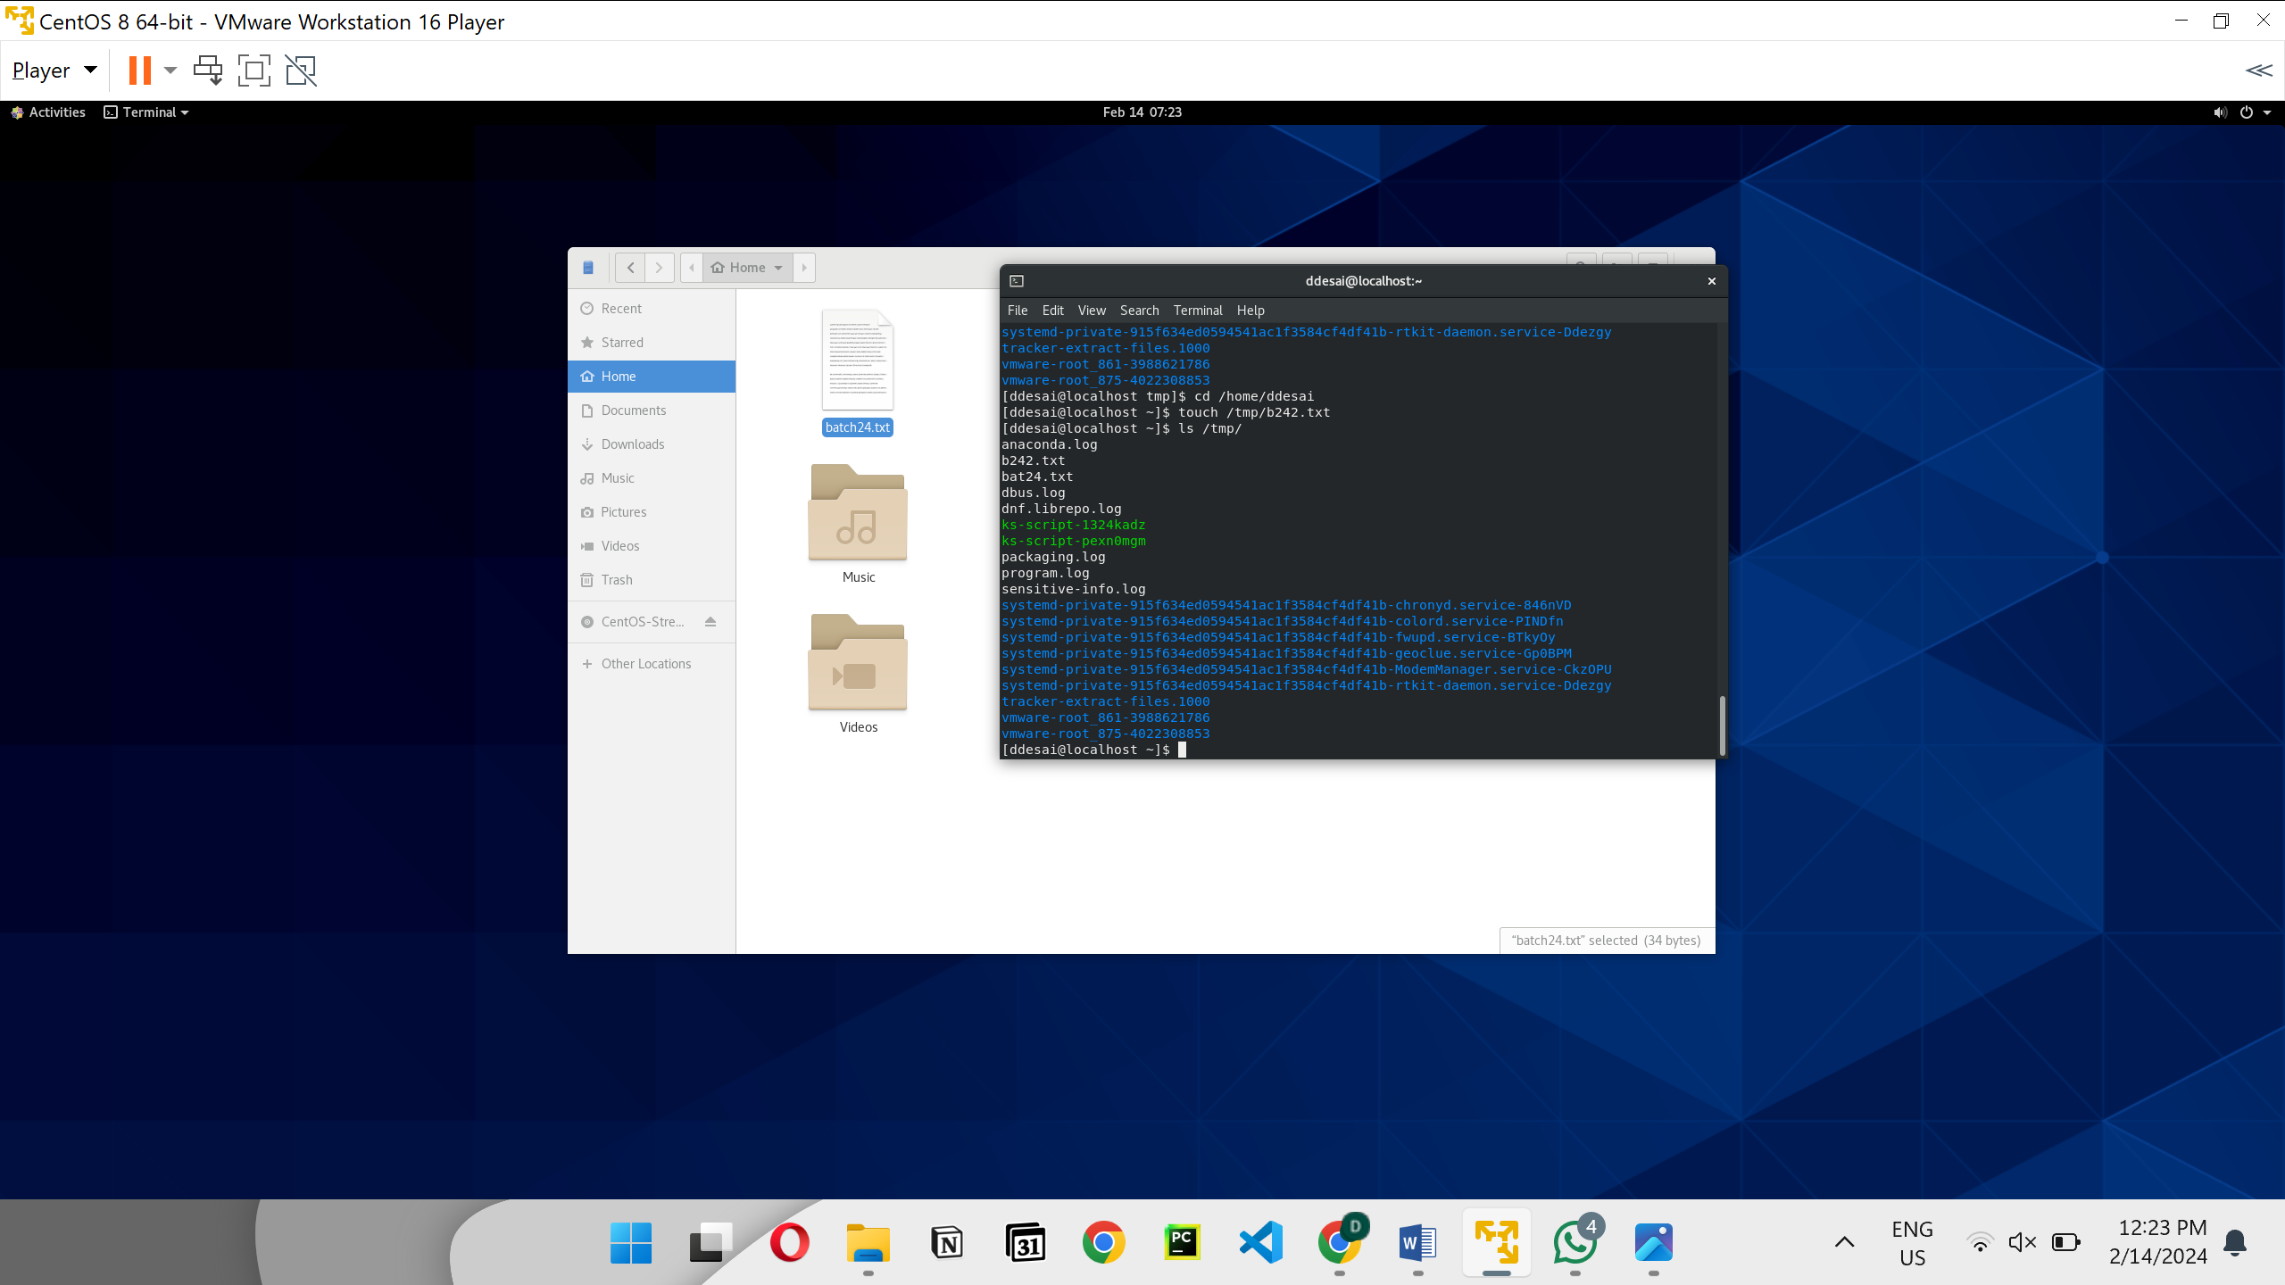

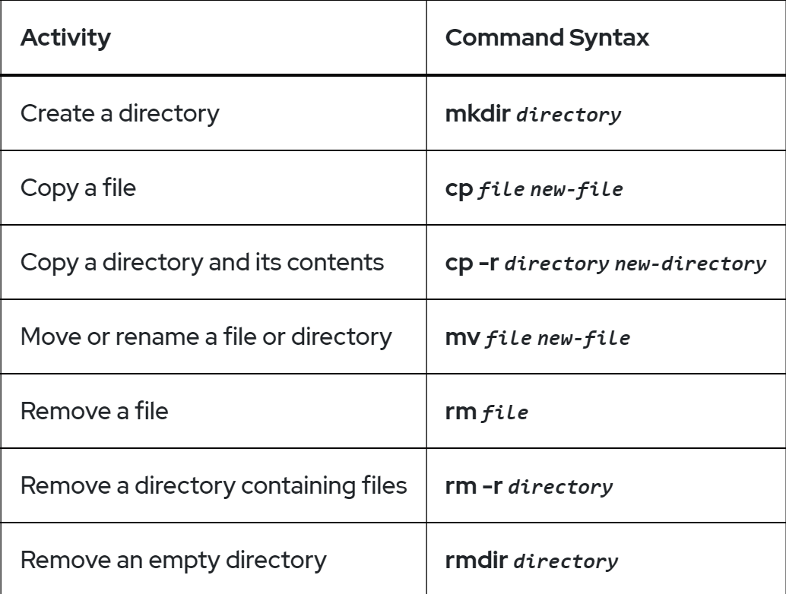

This to make directory:-

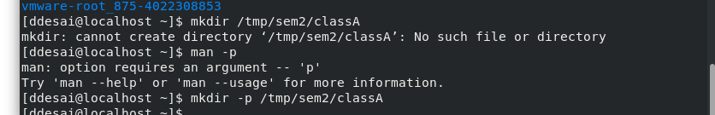

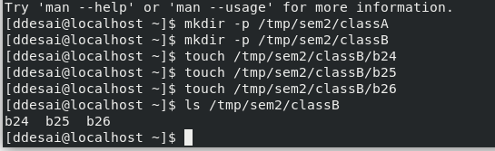

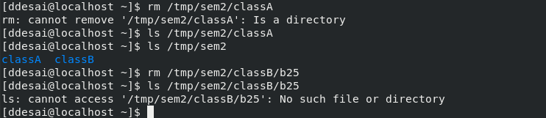

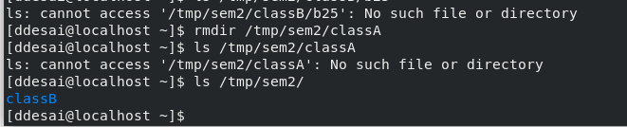



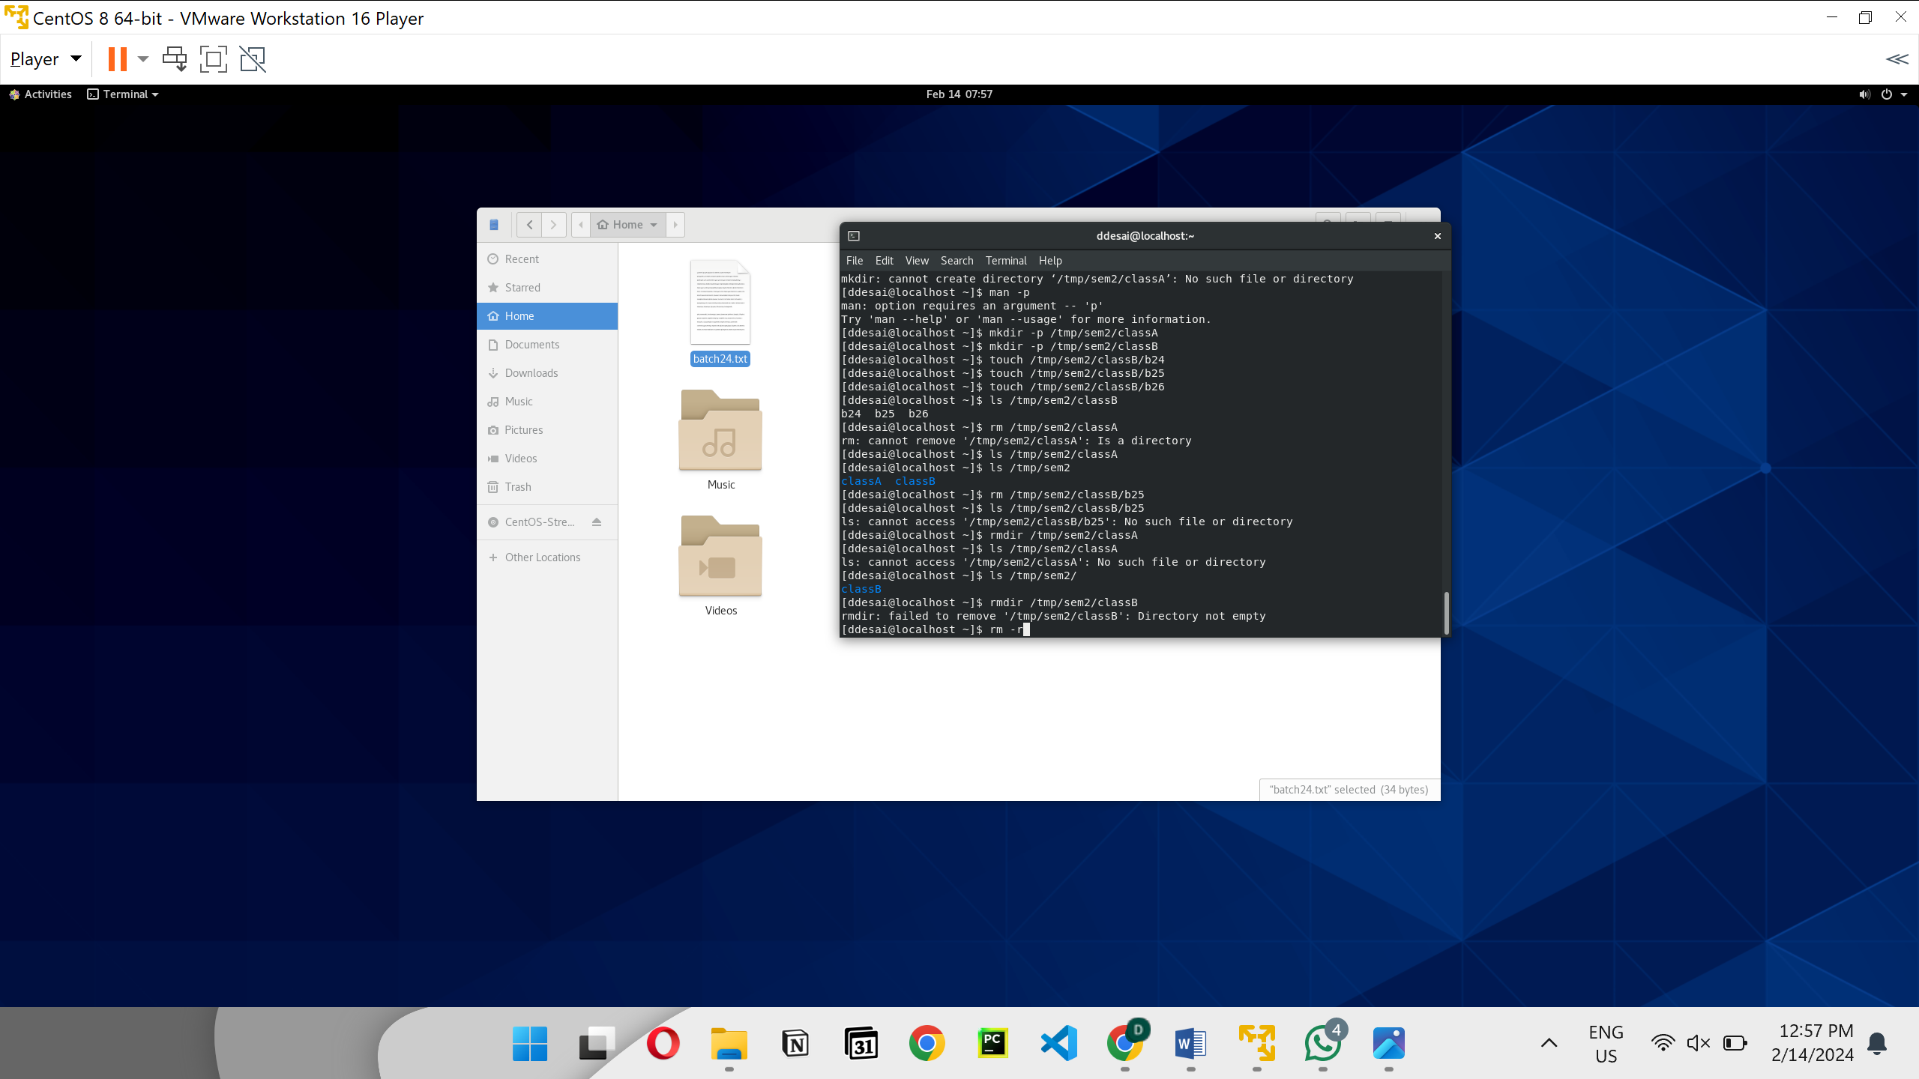

Coping file

“cp source destination”

If we don’t give name it will just write same name.

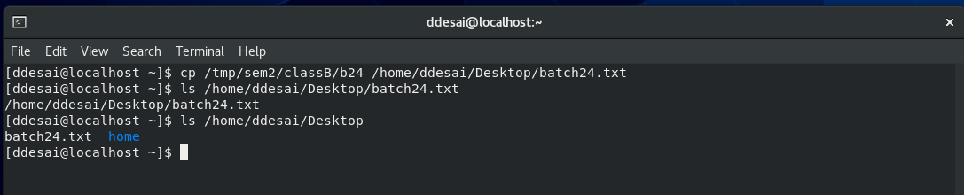

‘move opration’

mv source destination

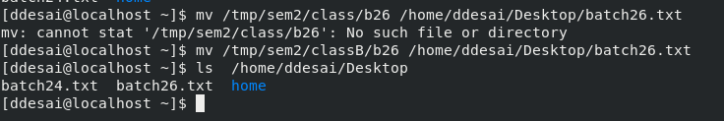

Mv can be also used for rename

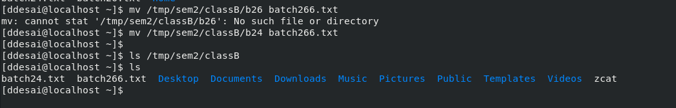



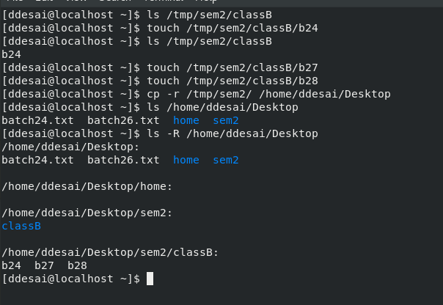

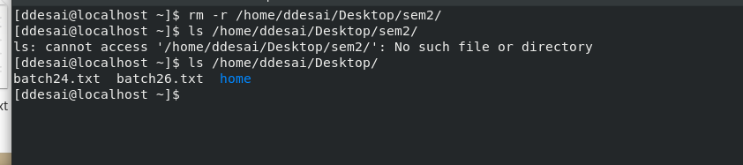

Hard link

This file can be created using 2 links



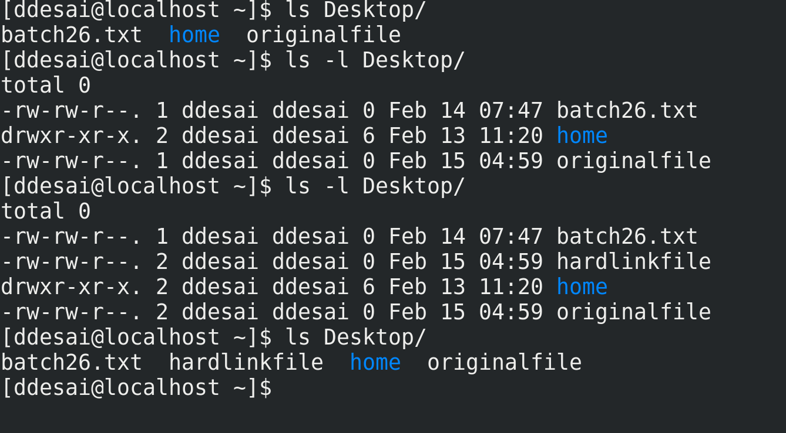

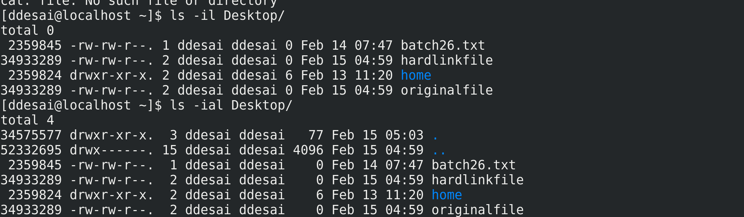

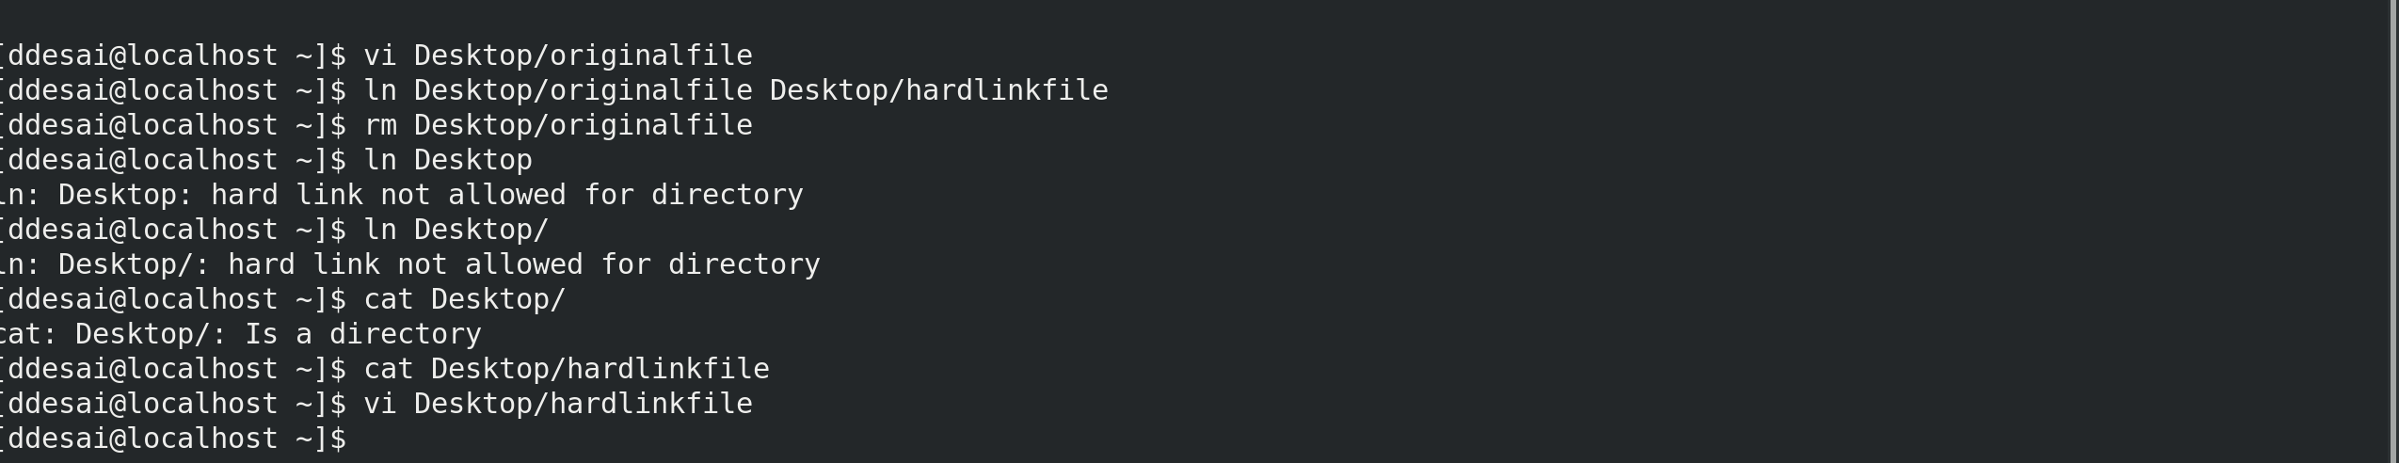

Soft link

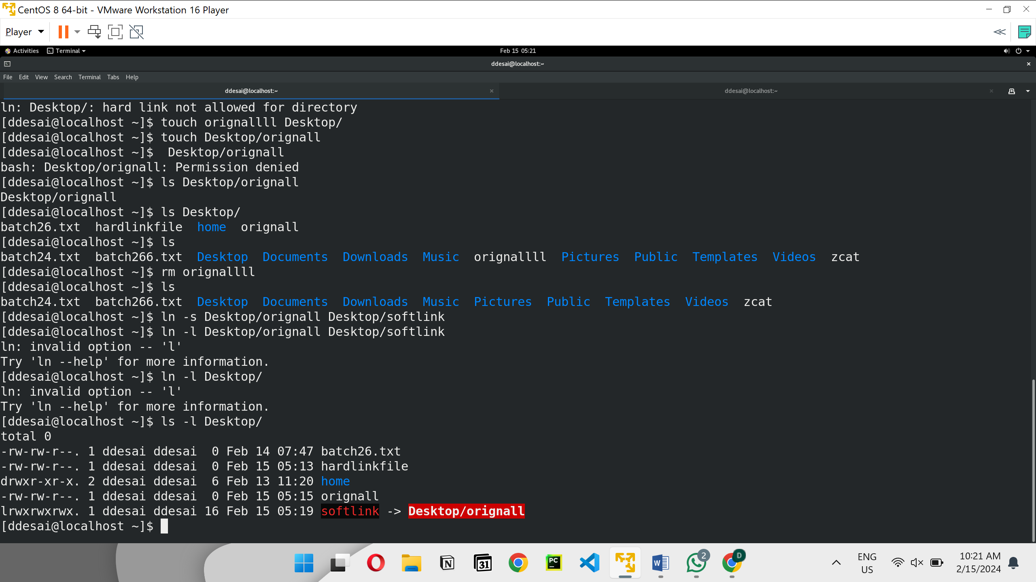

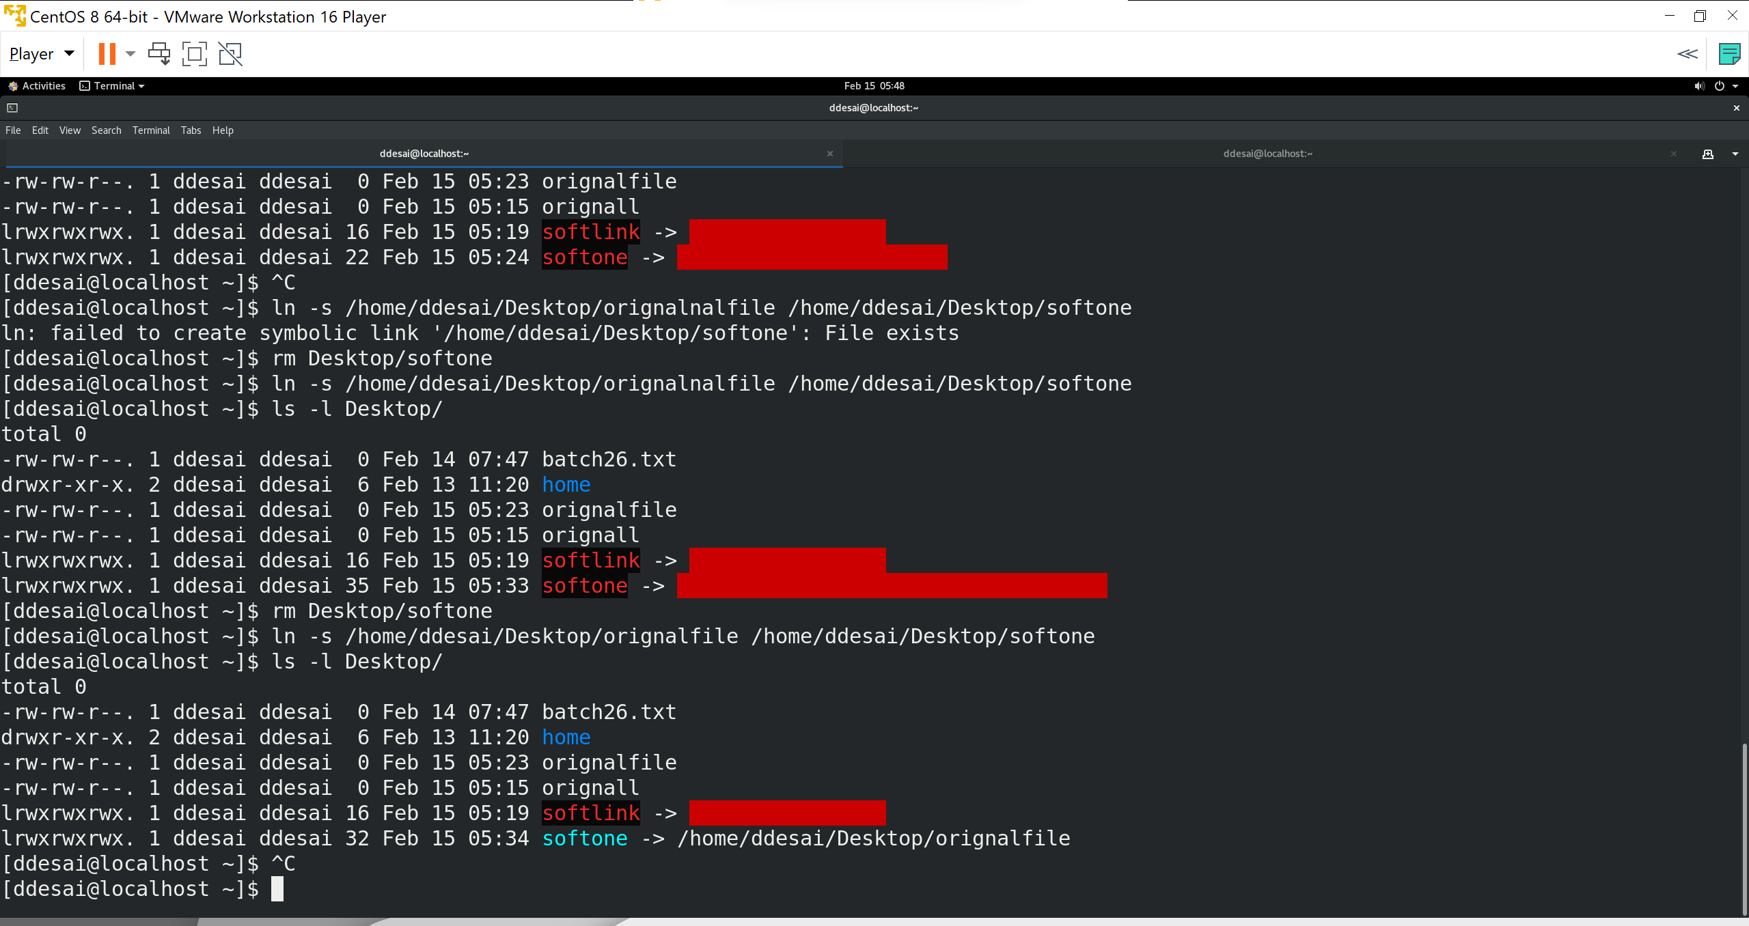

## Topic:- Matching File Names with Shell Expansions

Objectives

**saurch**

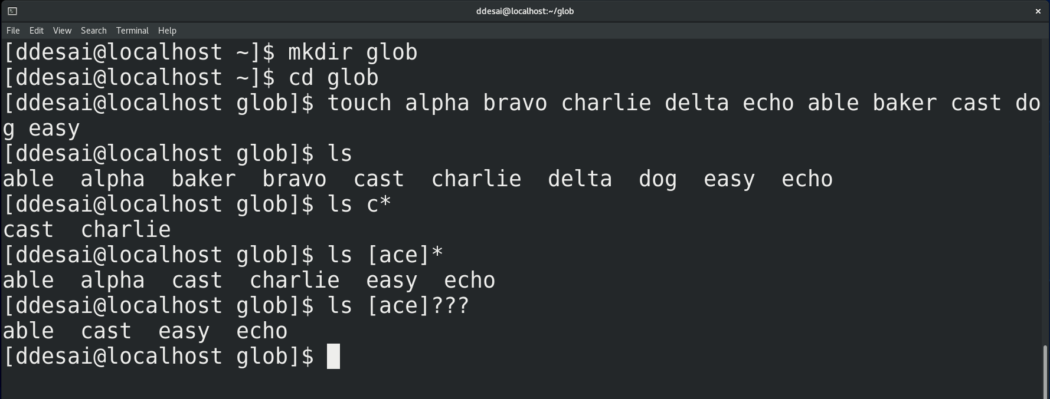

Creat file

Type-1

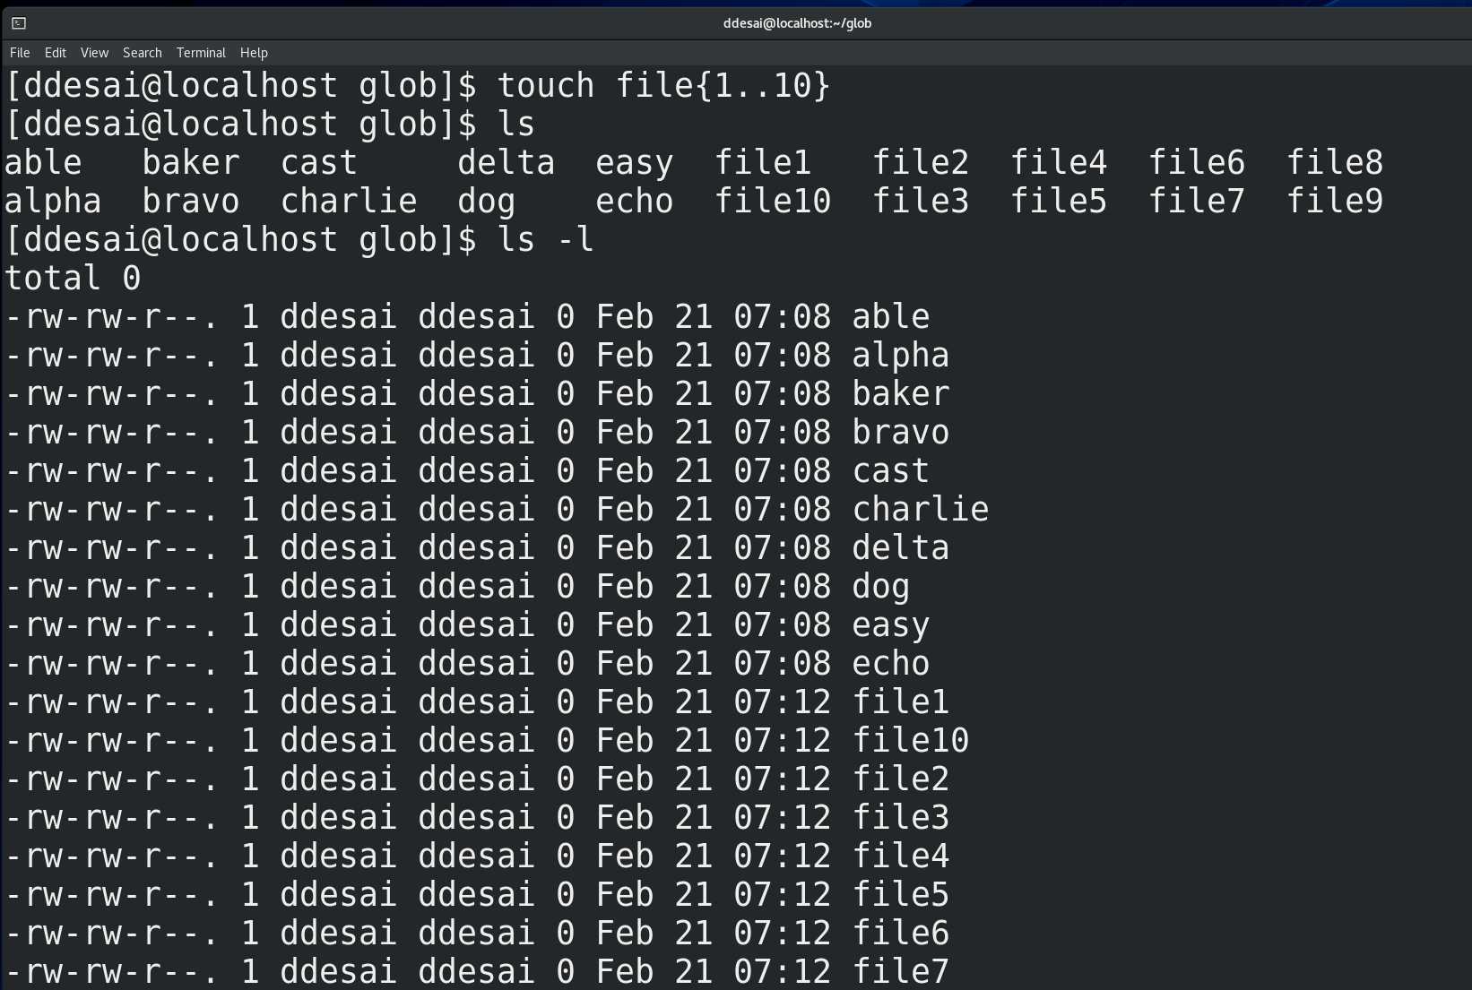

Type-2

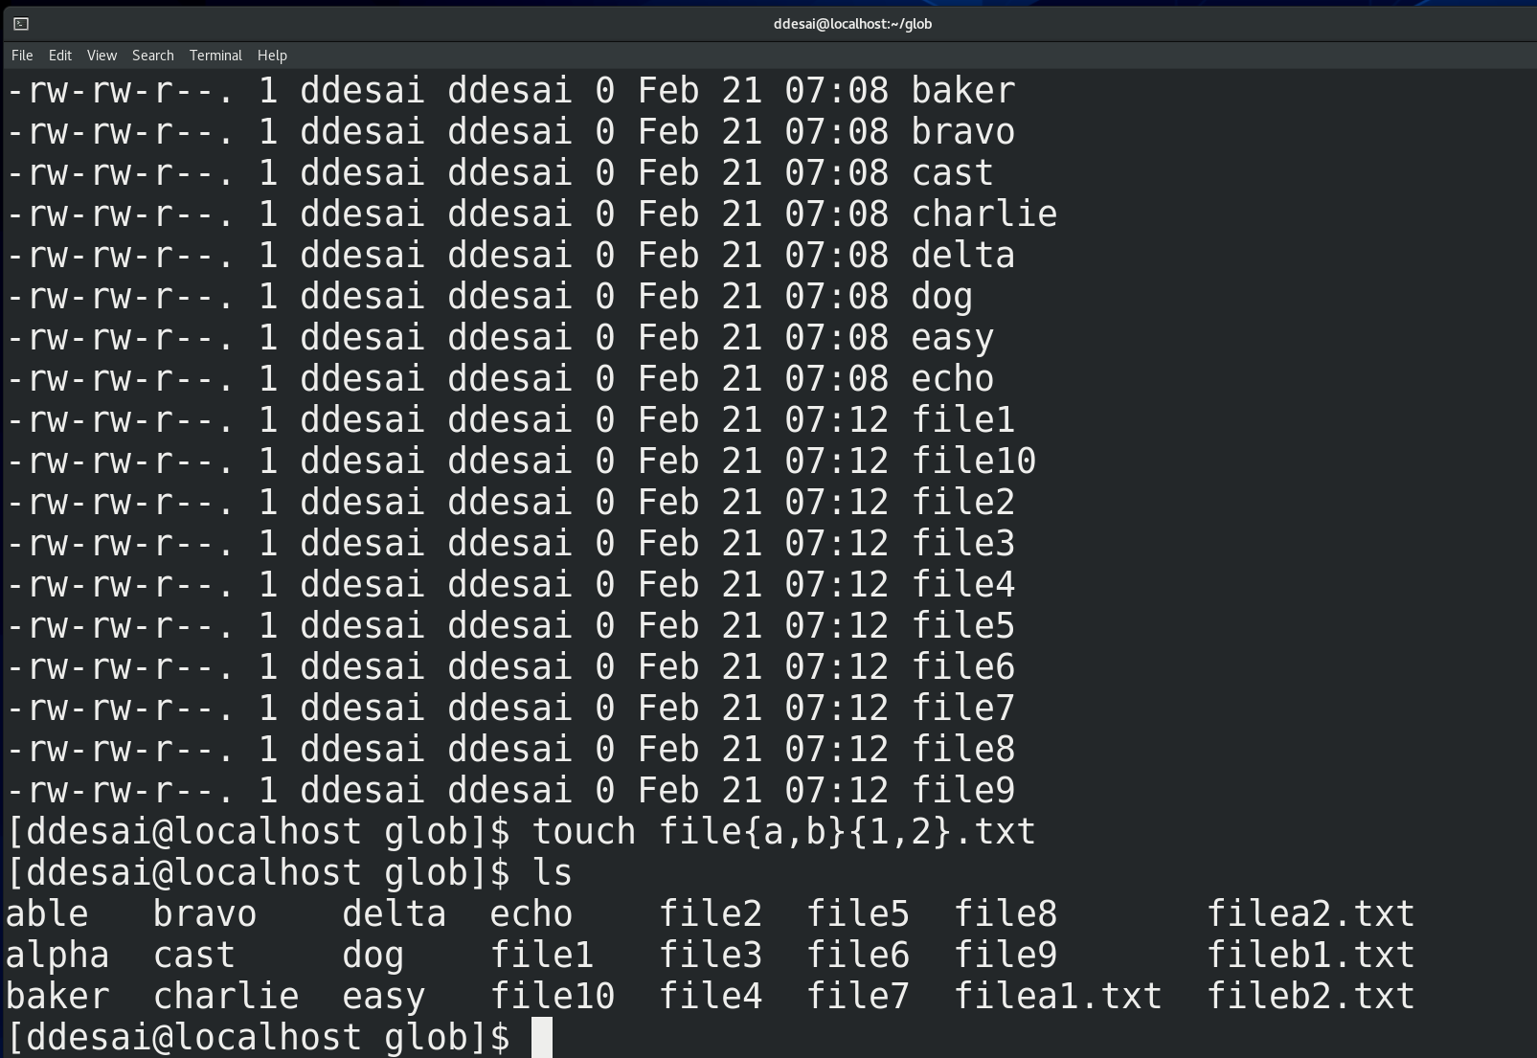

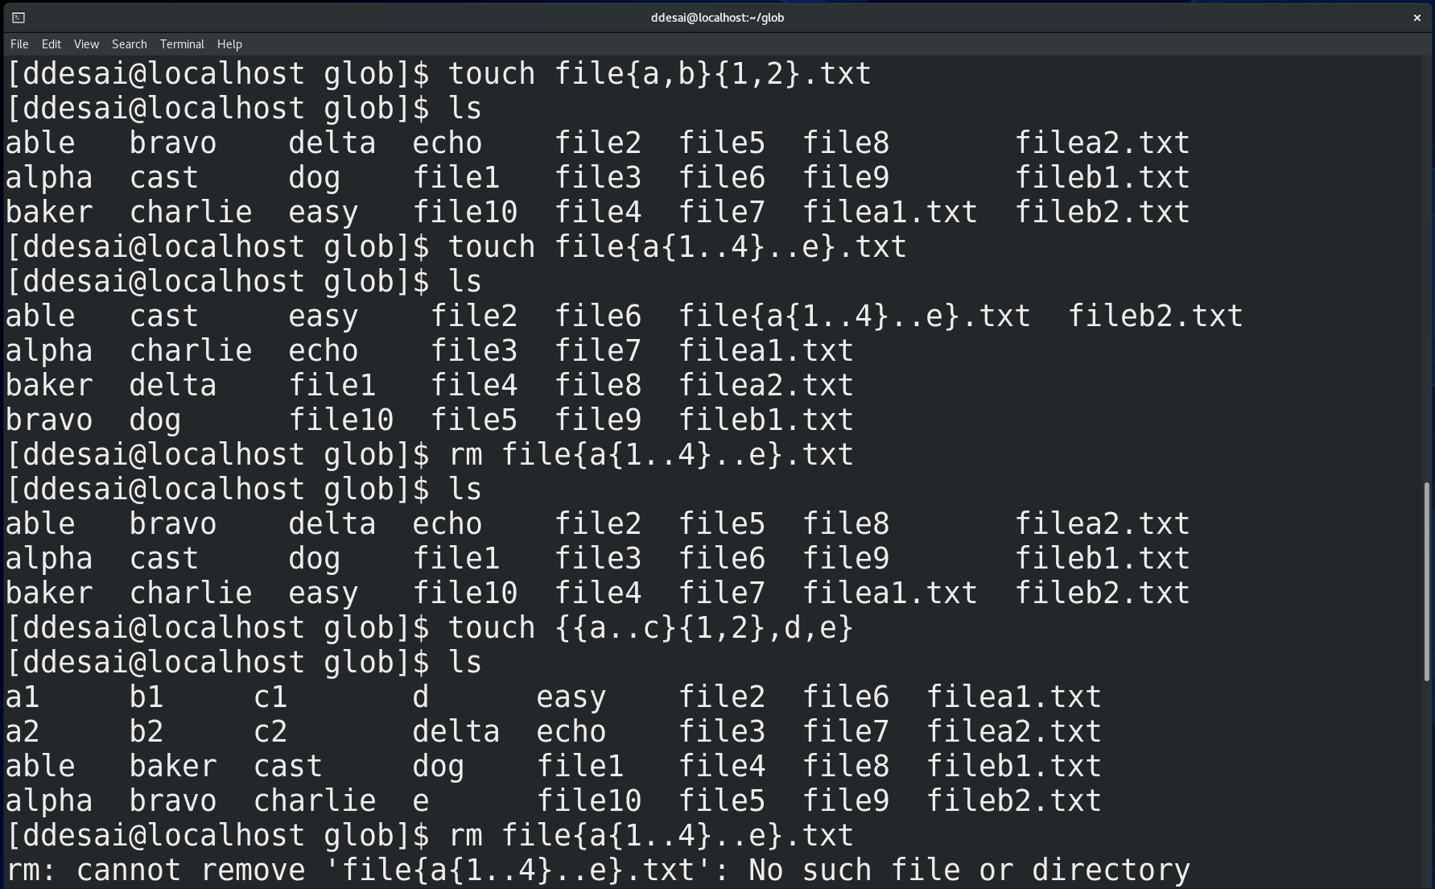

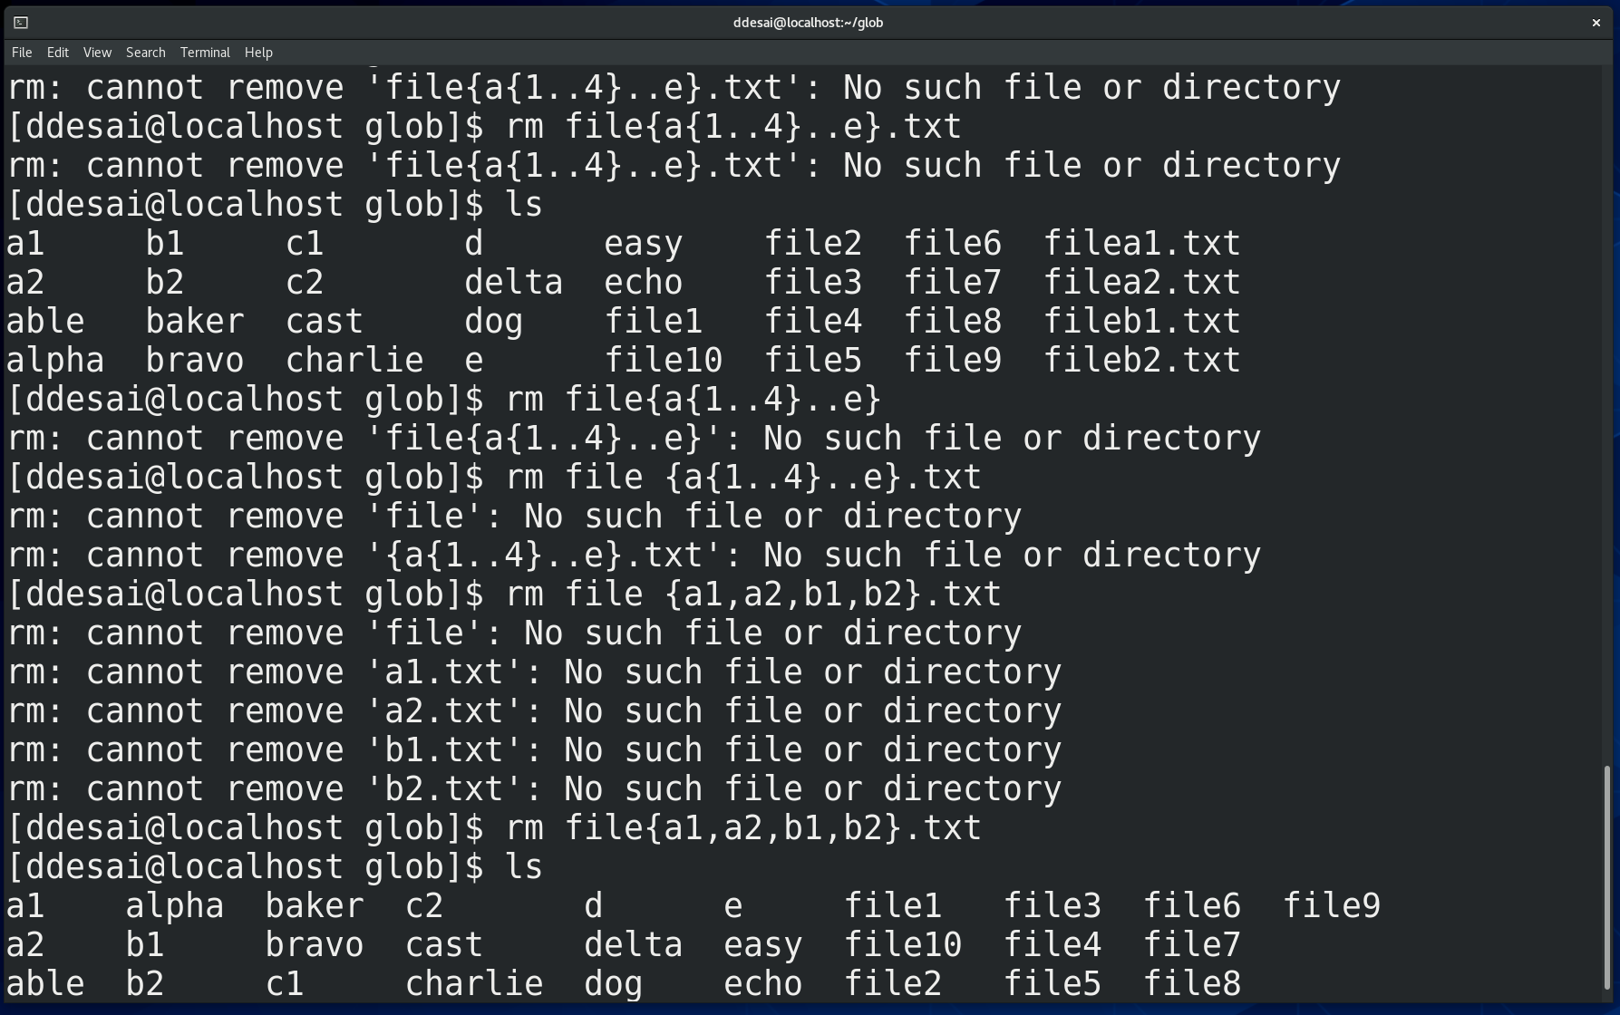

Echo:-

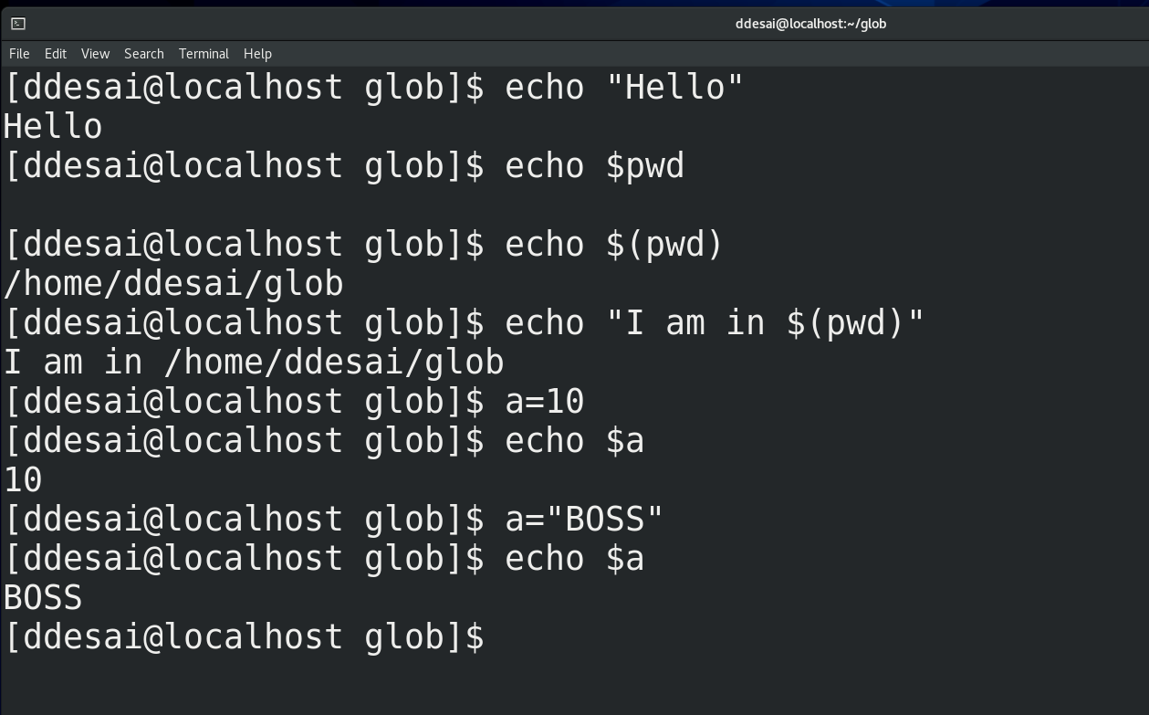

Use of $ with out it’s use

